**SPRINT - 4**

**TRANSMITTING THE DATABASE FROM THE CLOUDANT TO THE NODE RED WEB APP UI CODE:**

import time

import sys

import ibmiotf.application import ibmiotf.device import random

#Provide your IBM Watson Device Credentials organization = "owxp6u"

deviceType = "Smartbin" deviceId = "Bin1" authMethod = "token" authToken= "12345678910" # Initialize GPIO

def myCommandCallback(cmd):

print("Command received: %s" % cmd.data['command']) status=cmd.data['command']

if status=="lighton": print ("led is on")

else :

print ("led is off")

try:

deviceOptions = {"org": organization, "type": deviceType, "id": deviceId, "auth-method": authMethod, "auth-token": authToken}

deviceCli = ibmiotf.device.Client(deviceOptions) #..............................................

except Exception as e:

print("Caught exception connecting device: %s" % str(e)) sys.exit()

# Connect and send a datapoint "hello" with value "world" into the cloud as an event of type "greeting" 10 times

deviceCli.connect()

while True:

#Get Sensor Data from DHT11 time.sleep(5) ultrasensor=random.randint(0,80) capacity=random.randint(0,100) lat=round(random.uniform(12.03,13.05),6) lon=round(random.uniform(80.80,85.90),6)

data = { 'ultrasonicsensor' : ultrasensor, 'capacity': capacity,'lat':lat,'lom':lon} #print data

def myOnPublishCallback():

print ("Published ultrasonicsensor = %s Cm" % ultrasensor, "capacity= %s kg" % capacity,"lat:%s"%lat,"lon:%s"%lon)

success = deviceCli.publishEvent("IoTSensor", "json", data, qos=0, on_publish=myOnPublishCallback)

if not success:

print("Not connected to IoTF") time.sleep(1)

deviceCli.commandCallback = myCommandCallback

# Disconnect the device and application from the cloud deviceCli.disconnect()

**PYTHON OUTPUT:**

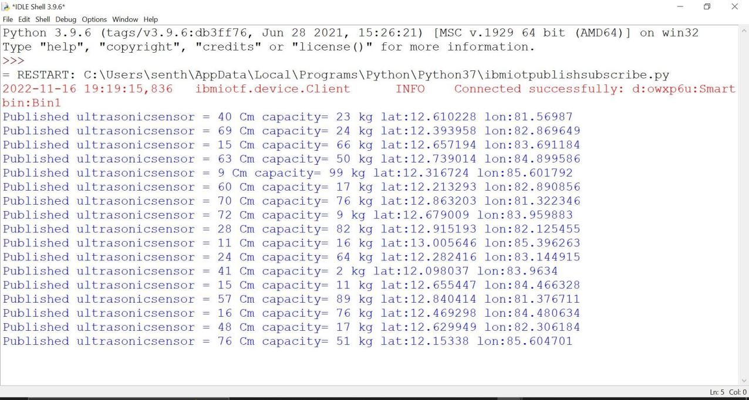

**CLOUDANT METADATA:**

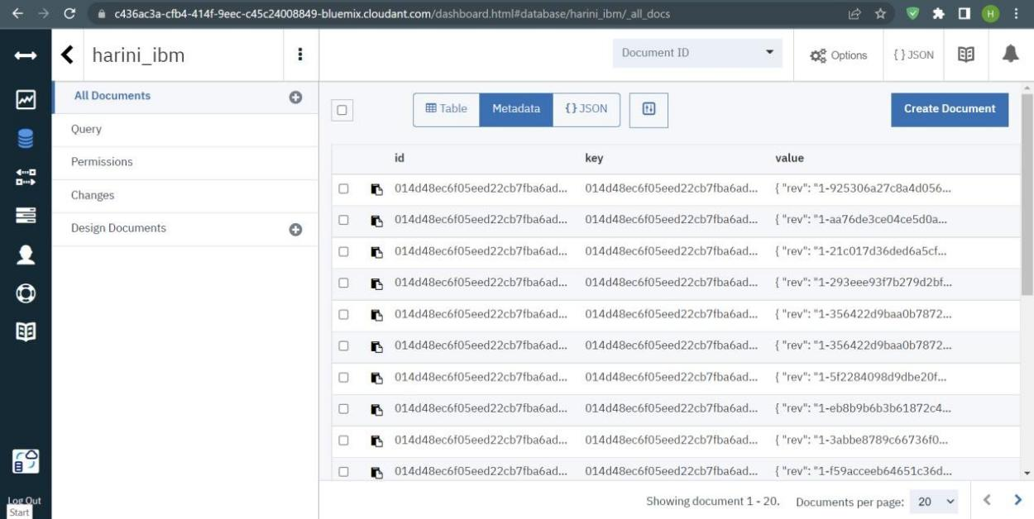

**CLOUDANT METADATA INFO:**

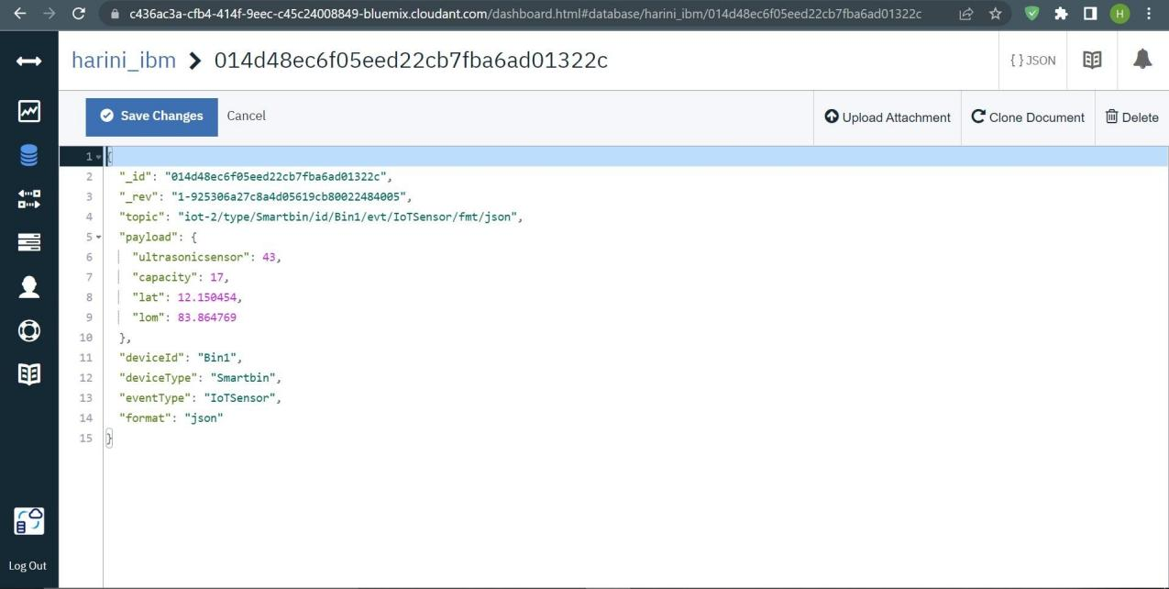

**CLOUDANT DIAGRAM:**

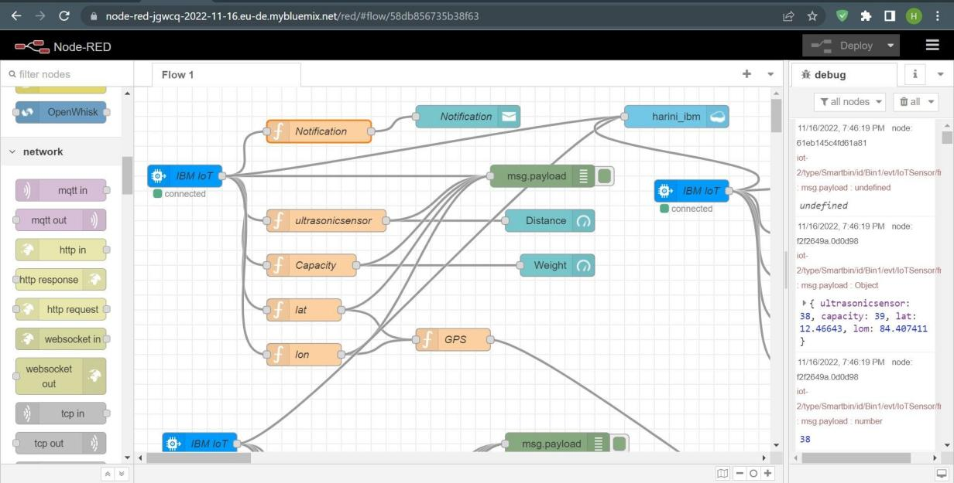

**JSON CODE:**

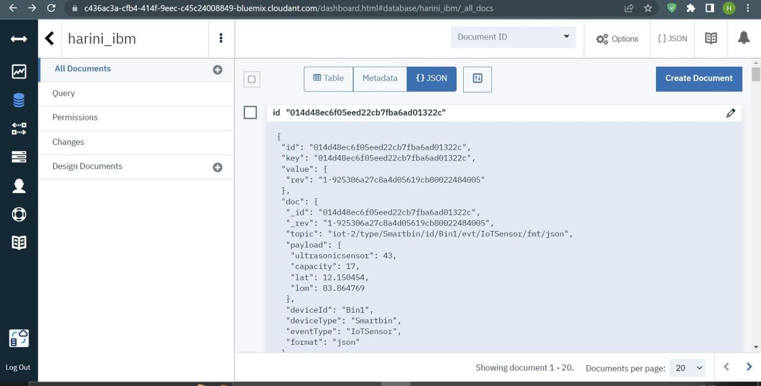

**CLOUDANT DOCUMENT:**

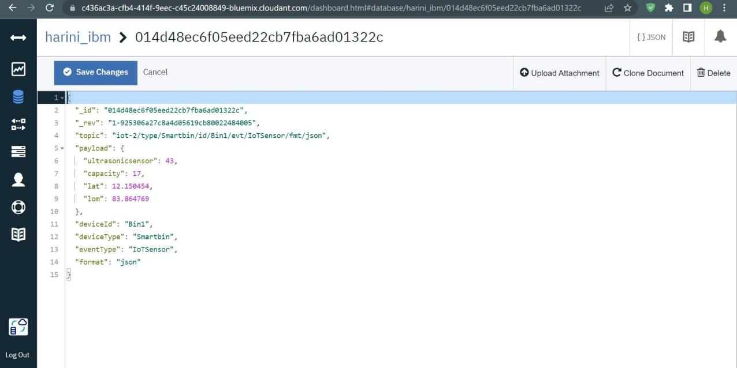

**RESULT:**

**The node red web app UI was used to successfully create the cloudant database.The cloudant was able to correctly store the data.**